MODULAR JS APPROACH FOR DYNAMIC CSS GENERATION AND UI MANAGEMENT
INTRODUCTION
Throughout history, humans have continuously developed tools that reduce effort while improving efficiency. From the invention of the wheel to the development of modern programming languages and software libraries, technological progress has largely been driven by the desire to automate repetitive tasks and improve productivity.
ACKNOWLEDGEMENTS AND CONTACT
This journal contains the functionality of the JS modules I coded 4 years ago to help me code with less effort and more efficiency. This paper presents a collection of JavaScript modules originally developed to reduce repetitive coding tasks during web development.
NAME: S HARISANTH KUMAR
CLASS: 12 – A
SCHOOL NAME: CHINMAYA VIDYALAYA
CONTACT: 9840097027, sensakharisows@gmail.com
OVERVIEW
Modules and libraries are created to reduce repetitive tasks. There are many popular free modules and libraries available for varying purposes. This journal will discuss 3 modules which will help overcome this problem
Setup JS:
Setup JS is a simple JS module created to set up the foundation of a website. It is simply a module which globalizes all the functions predefined by the programmer for his/her easy access. It also provides functions and objects which can be used in other modules.
Response JS:
A module which interlinks CSS and JS allowing the programmer to change CSS properties using variables and conditions, giving us various new and shorter ways to design our websites
Modal JS:
It is a simple module which creates popups responsive to all screen sizes, with yes, no buttons (user defined functionality) and close button. It can be used to display error messages, ask confirmations, etc.

PROBLEM STATEMENT AND SOLUTION
HTML the skeleton, CSS the art, and JS the logic. Among these 3 languages, JS is the most dynamic. I found it time consuming to change the CSS properties dynamically to create responsive websites.
CSS libraries are often restricted to certain functions and used in classes which are non-customizable. In short, these are too restrictive. Although vanilla JS is the purest form and offers maximum freedom it is too plain and is repetitive. Therefore, I created response JS as a dynamic interlink between JS and CSS, offering freedom to code as you like. The dynamic CSS code is written in Json like format. it is friendly with all attributes and even HTML DOM objects. Using response JS, one can introduce logic into the world of design. Apart from response JS, there are a few other simple, yet useful functions which can shorten many lines of repetitive code into a few words, making the program look crisp, readable, and short.
Key Features of Response JS
- Conditional CSS rules
- Dynamic value computation
- Runtime CSS generation
- Automatic responsive updates
- Min-max value constraints
- Multi-part CSS values

ALL MODULAR FUNCTIONS DEFINITION AND FUNCTIONALITY DOCUMENTATION
g (<name>, [<value>]):
If value is specified
1. It can create a new global variable
2. it can change the value of existing global variables
If not specified
3. it returns the value of the existing global variable
This function has been used throughout the other modules, making setup js a must to work with the other 2 modules
load_setupjs (callback function):
executes this module and calls the callback function when done
ele ():
Returns the html element as an object to work with in JS
num (<“----px”>):
returns a number after removing “px” from the end.
s1 (<code>):
static CSS style (permanent)
s (<code>):
dynamic CSS style
get (<attribute name/HTML DOM object>, <CSS property>, <boolean>):
returns CSS property of given attribute or object. Removes px if Boolean is true.
defaultcss ():
is the default CSS injected into s style
loadwebsite ():
A simple loading screen created by this module is turned off once this is called
load_responsejs (callback function):
executes this module and calls the callback function when done
apart from the prebuilt static stylesheets, there are 2 CSS style tags.
s1: to insert new permanent CSS code during runtime
s: highly customizable CSS code which can work on variables and conditions
to use s1, directly use the s1() function which appends any new CSS code into the HTML style tag
response JS works on s
response_fun:
Variable storing all the dynamic CSS functions in non-executable list format
response(<attribute/HTML DOM object>, <CSS function>):
a function which takes in attribute, or object and its dynamic CSS function and appends it to response_fun list.
response_run (<CSS function>):
takes in a CSS function and parses it into pure CSS.
response_data:
the pure CSS gets stored here
respons(<callback function>):
1.declares global variables w and h as the inner widths and heights of the window
2.parses every CSS function in response_fun into response one by one to obtain the complete pure CSS in response_data
3.sets s to response_data (<style> </style> tags)
4.calls the callback function
5. is the main execution function and is automatically called on window resize and can be called manually too.
load_modaljs (callback function):
executes this module and calls the callback function when done

modal(<title>, <message>, <num>, <extra content>):
button display:
num=1 => yes, no
num=2 => close
num=3 => yes, close
num=4 => no, close
where functions yes () and no () are defined by programmer before calling modal ()

RESPONSE JS SYNTAX
In the function, response (para1, para2):
“.<class>” / ”#<id>” / ”<html tag>” / HTML DOM object is the first parameter and is used to reference an attribute to which the rules are applied
The second parameter is a string of a Json like format:
‘{<property1>: [<value obj>]
<property2>: [<value obj>]
…..}’
Where the properties are real CSS property names
The object is to be finally enclosed in quotes so that it is a non-executable string
[<value obj>]:
1. It is of minimum size 1
2. It can have any number of conditional values
3. May or may not have default values
4. each value and condition in the object is entered inside list brackets []
5. In case the property requires the entry of multiple values, the [] are separated by comma
6. conditions are paired with their values inside curly brackets
7. both condition and value are valid JS expressions
8. It follows order and is overwritten by succeeding values, so it is recommended to keep the default value at the first position followed by conditions in increasing order of priority
syntax
[ “<default>” ]
[{
cond: [<statement>], value: [ [<statement1>], [<statement2>], [<statement3>], …..]
}]
Example with multiple values:
padding: [{cond: [w <= 600],
value: [['0px '], ['15px '], ['0px '], ['15px']]
}]
example of its usage (modal JS)
response (modal1, `{
width: [ '500px',
{cond: [w <= 620], value: [ [w * 90 / 100 - 50 + 'px']] },
{cond: [w <= 370], value: [ [w * 85 / 100 - 50 + 'px']] }],
padding: [ '15px', {cond: [w <= 370], value: [ ['10px']] }]
}`);

Built in condition check:
Min – max
Syntax
‘{<property>: [[num, {min: num, max: num}], [], [], ….]}’
Ensures that the value doesn’t go off limits

Example
‘{width: [[w * 0.9, {min: 300, max: 600}]]}’

SYSTEM FLOW DIAGRAM
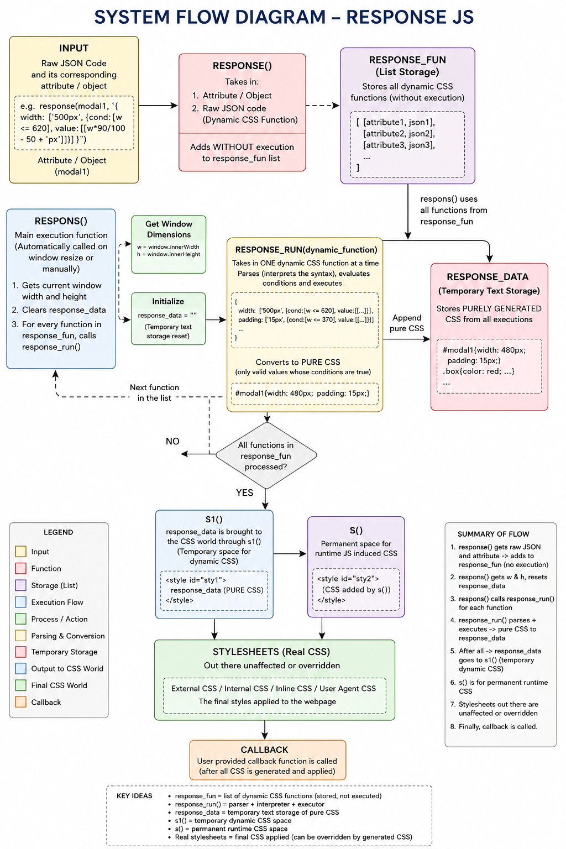
MODAL JS EXAMPLE OUTPUT
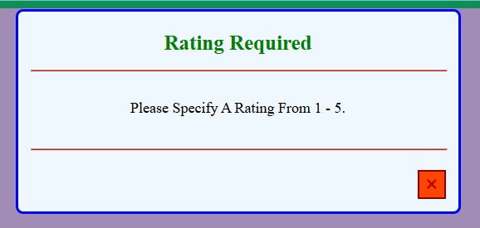
COMPARISION
Feature | Traditional CSS | Response JS
Conditions | Media Queries | JS Expressions
Dynamic Values | Limited | Full JS Support
Runtime Updates | Difficult | Built-in
Responsive Design | Manual | Automatic

METHODOLOGY
1. Designing syntax to cover all aspects of CSS (except media functions)
2. Making HTML DOM elements and their properties every easily accessible using get () and ele () functions
3. Creating a space to store the JS – CSS dynamic functions in string format for parsing anytime
4. to manage overwrite so that the highest priority instruction is the one to be effective
5. Creating an appropriate translator which uses the designed syntax to properly decode and execute all the code returning pure CSS
6. Using a function to iterate through and parse all the functions and deploying them in a space exclusive for dynamic CSS
7. rendering this function under criteria like window size change, or time interval, etc.
8. callback once process is successful

RESULTS AND DISCUSSION
We now have a way to fully control our websites design with conditions and logic using this CSS – JS interlink module called response JS. We also have setup JS to establish a basic framework of self-defined functions and to support self-written modules. Using response JS and setup JS we have a functional and responsive popup module and a simple loading screen until the website is ready to display.
=> reduced code repetition
=> responsive UI generation
=> ability to use JS variables directly in styling
=> modularity
=> ease of creating popups
CONCLUSION AND FUTURE WORK
1. error handling is to be enforced
2. global identifiers in modules must be listed and managed to prevent duplication
3. parsing repetitively increases process time. By adding appropriate time intervals or by simplifying certain parts of the module we can reduce process time and delay
LINKS
Files of setup JS, response JS, modal JS and flowchart of response JS can be viewed and downloaded on my GitHub site
https://github.com/lumi-xd/modular-js

